Conor Roberts #1056167

1. Q1
   1. Brute force
      1. **Design:** Approaching this problem logically, and inefficiently, the most simple method of brute forcing is to check for all inversions of each index of our data array. To accomplish this, I will construct a nested for loop. The outer layer will keep track of the element from which I will be comparing others and the inner layer will be the element to compare that to. The inner layer will iterate *n* times for each iteration of the outer layer. Thus, my algorithm will have an efficiency class of ${θ∈n}^{2}$
      2. Pseudocode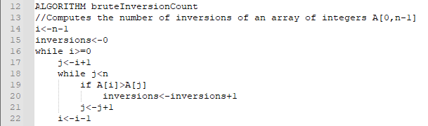
   2. Divide and conquer: My algorithm go brr
      1. This algorithm is $θ∈nlogn$
      2. Pseudocode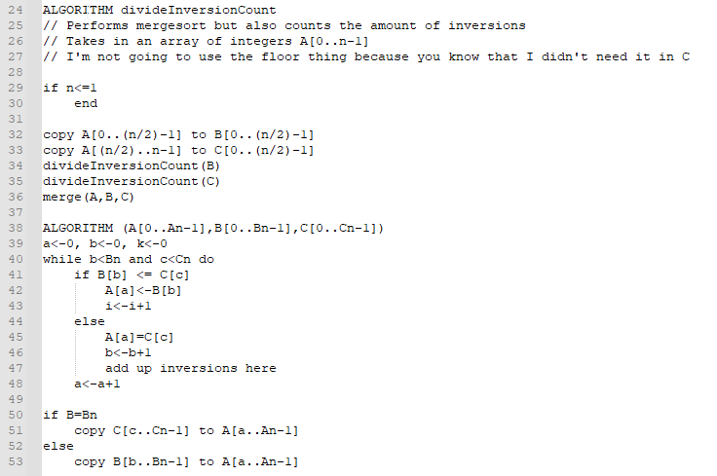
2. Q2
   1. Brute force
      1. Efficiency class of $θ∈n^{3}$
   2. Divide and conquer
      1. Efficiency $θ∈(nlogn)$